In the assignment i was given a tsk to create two new folders under the work space folder one for the “ArchOSC Assignment” and another folder for my saved screenshots then i was asked to screenshot the process and save it on the picture folder.

Then i opened the terminal by right clicking the mouse and by initiating the process by writing “git init”
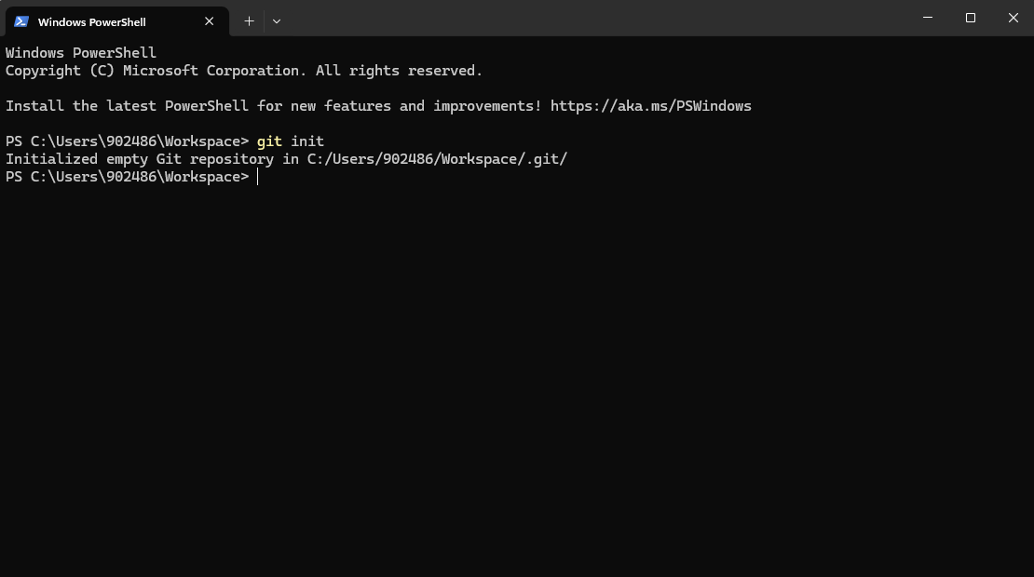

After creating a local repository i decided to create the new repository on git hub by assigning this name on it ARCHOSC-Assignment-claudiookeafor
As the new repository name and this is how it looks

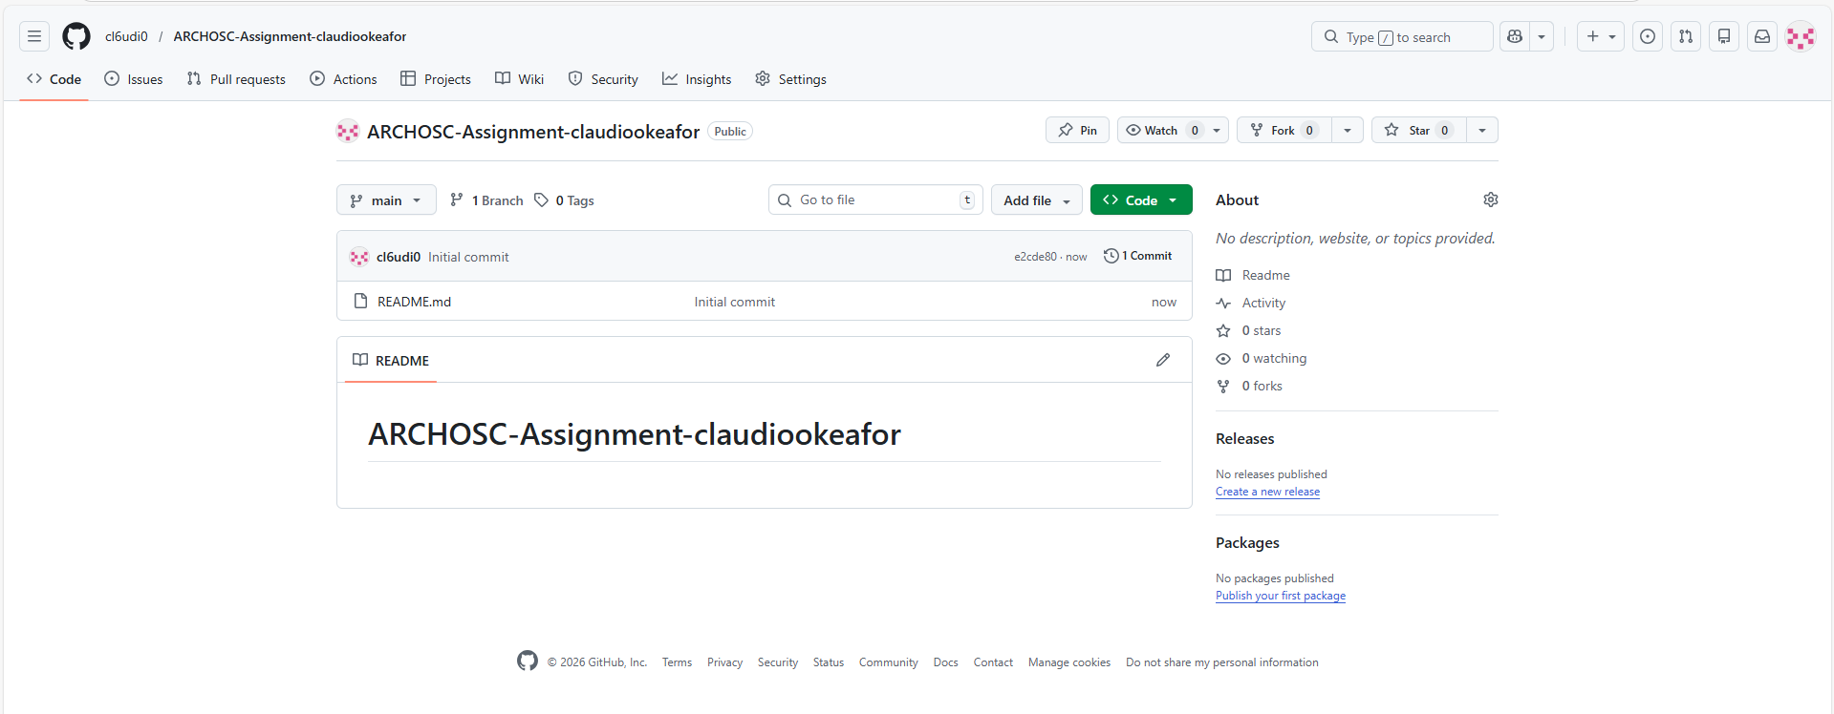
We then went back to the terminal and initiated a git init on the ArchOSC Assignment folder and added a git remote add origin with the link of the online github repository then initiated a git pull origin main 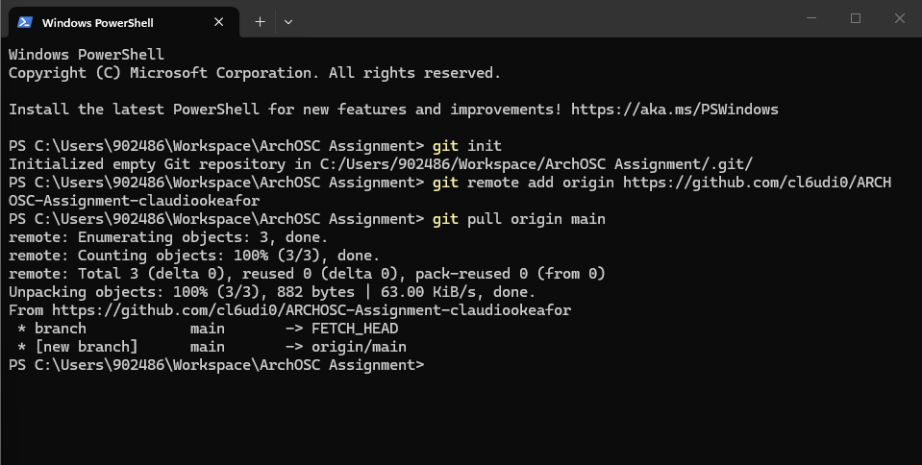

I opened a new file on visual studio code then copied the piece of code and saved it on my folder as index.html. Then i double clicked on it and open the web page 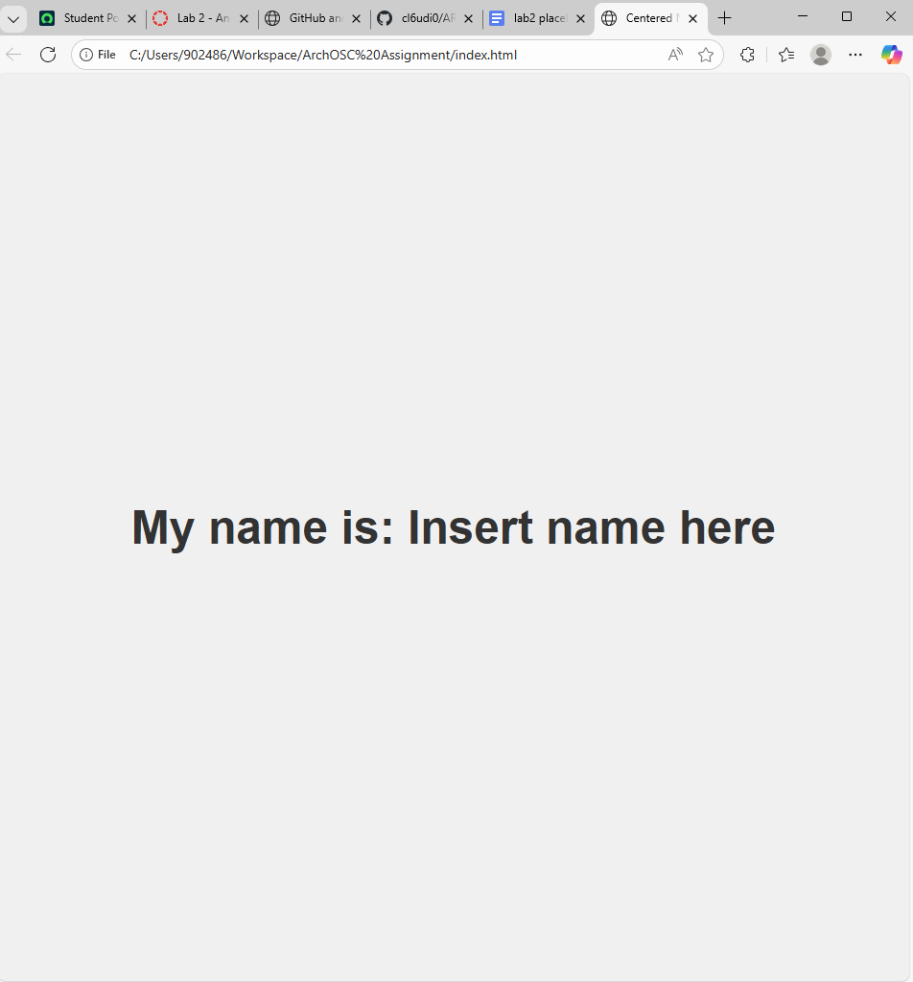
After creating the website shell i committed it to the github repository and i also added a git commit message 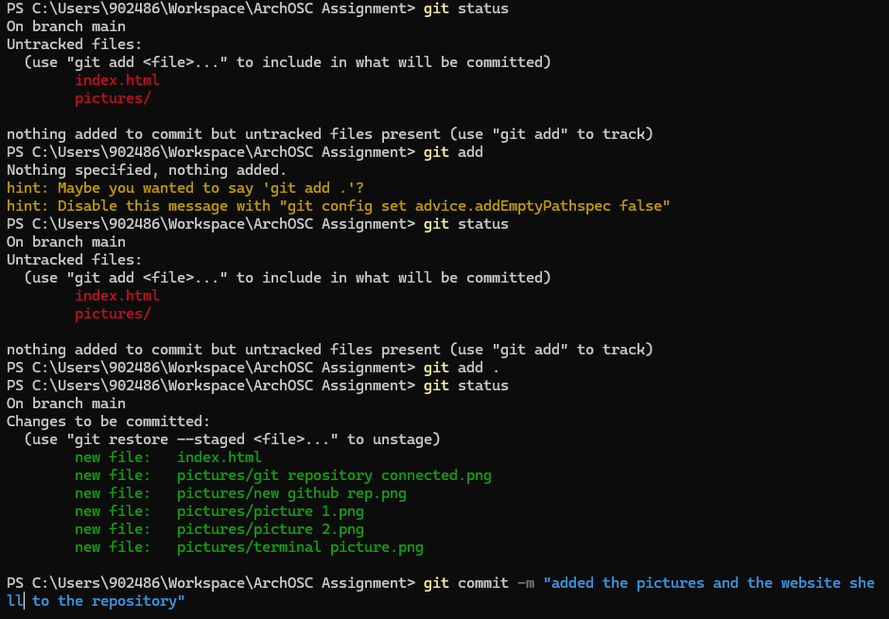
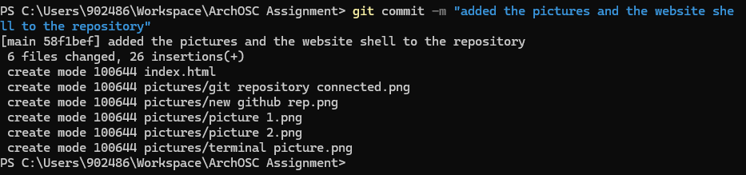
I then successfully was able to push all my work on git hub
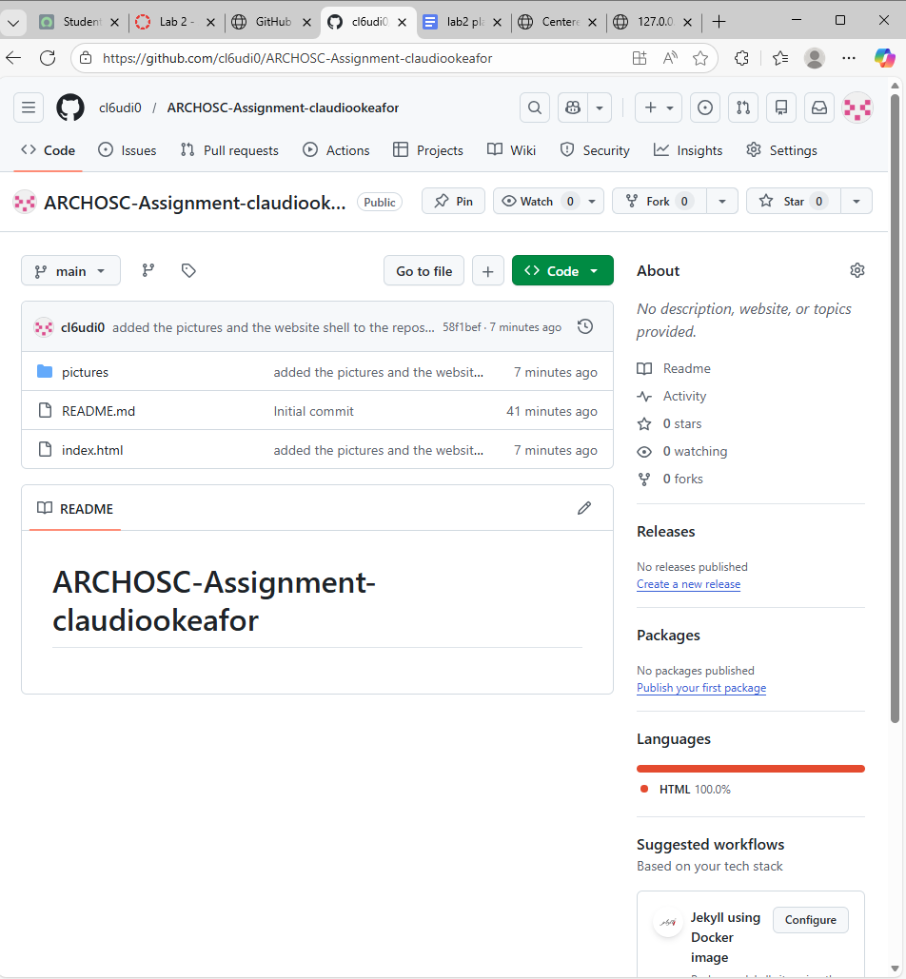

Improving website
I started by changing the background colour of my index page
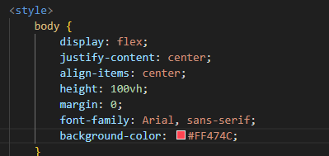

I also decided to add a search bar to the web page to make navigation easier

After the changes i decide to add the new additions to my website to my git hub by using git add the used git status to check if it was committed after that i committed ity and wrote a message fo reference 